CONUMER CLUB ACHIEVEMENTS – 2021 AND 2022

NATIONAL CONSUMER DAY WAS CONDUCTED IN OUR COLLEG ON 24.12.2022
In view of the above, Students Our college participated in District level and State level competitions of and won prizes too.
- P. LOKESH
- Y. JYOTHI
- P. PRAVALLIKA
- T. TULASI
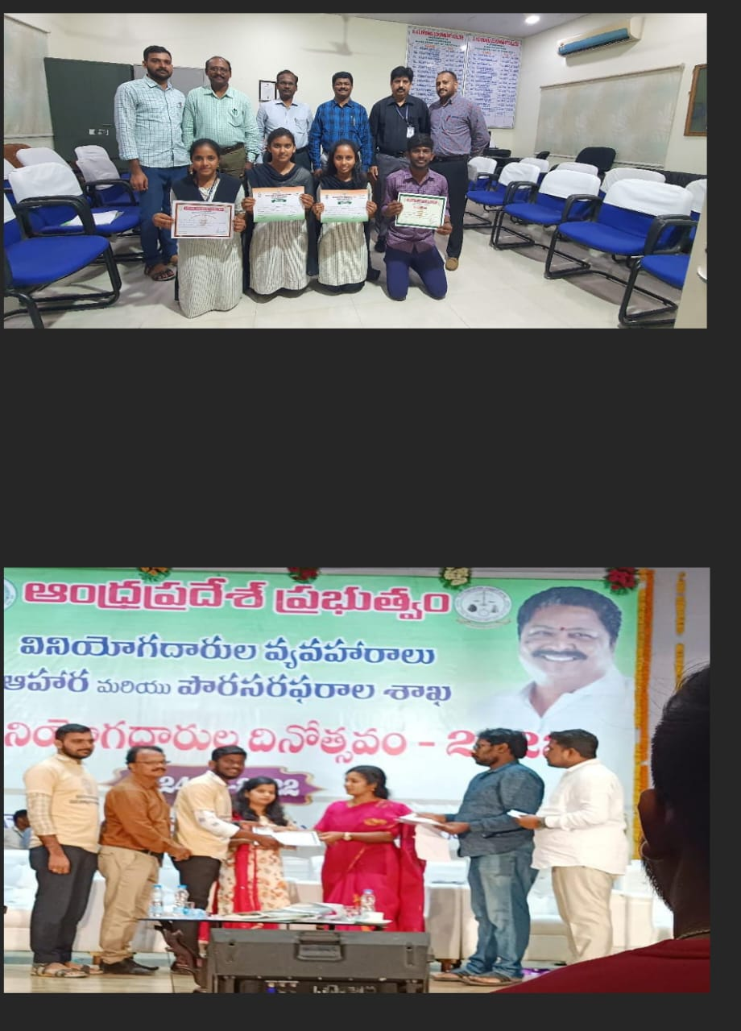

CONSUMER CLUB ACHIEVEMENTS – 2021
NATIONAL CONSUMER DAY WAS CONDUCTED IN OUR COLLEG ON 24.12.2021
In view of the above, Students Our college participated in District level and State level competitions of and won prizes too.
